**CS255 System Design Document Template**

Jonathan Brugh

Southern New Hampshire University

CS-255 System Analysis and Design

Dr. Goran Trajkovski

February 23, 2025

# CS 255 System Design Document Template

This template lays out all the different sections that you need to complete for Project Two. Each section has guidance to prompt your thinking. You will need to continually reference the interview transcript as you work to make sure that you are addressing your client’s needs. There is no required length for the final document. Instead the goal is to complete each section based on what your client’s needs are. Remove this note when you are finished, and replace all bracketed text with the relevant information.

## UML Diagrams

### UML Use Case Diagram

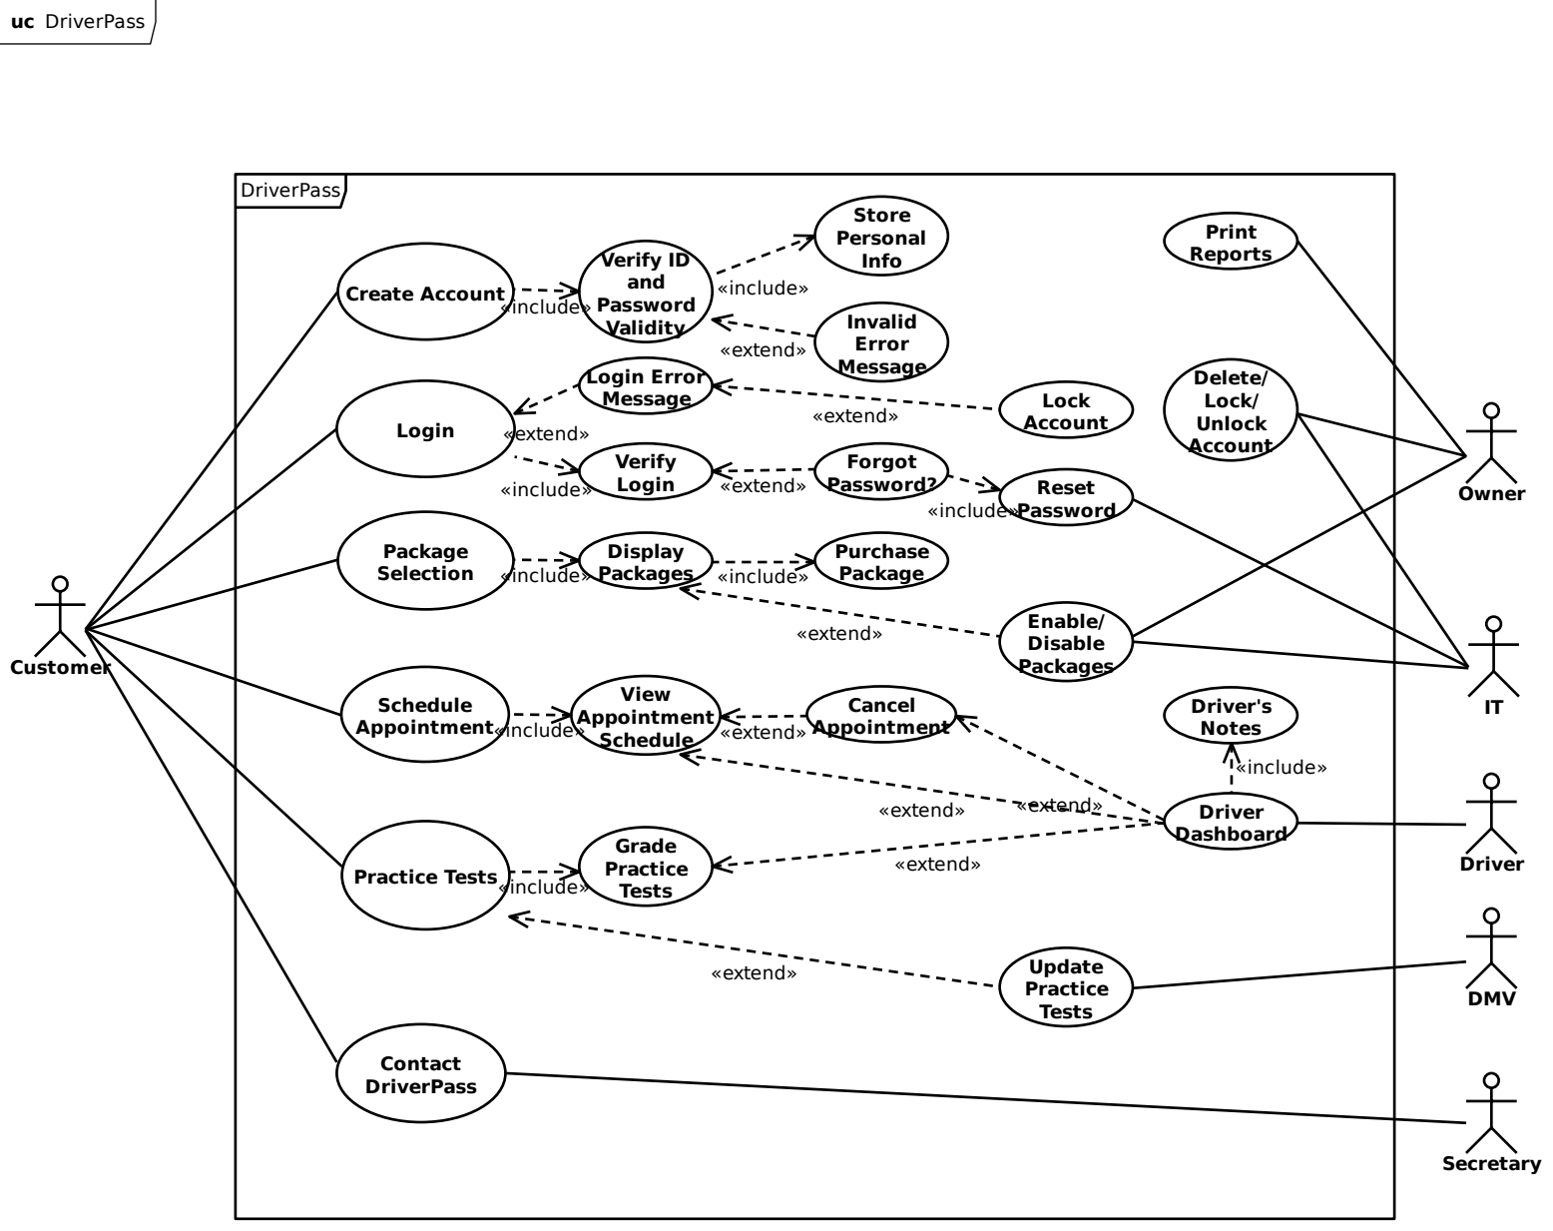

### UML Activity Diagrams

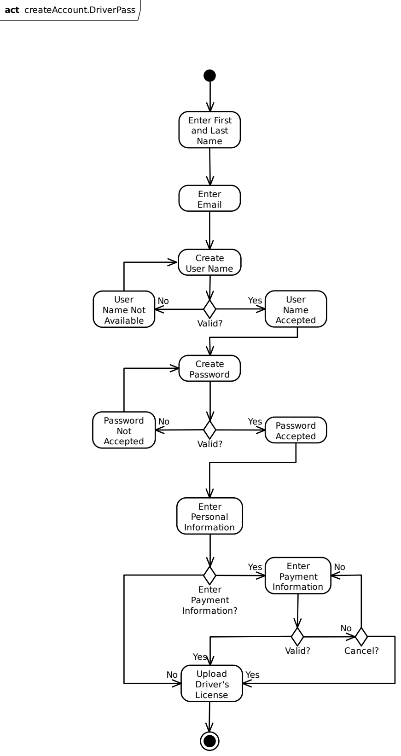

### 

### UML Sequence Diagram

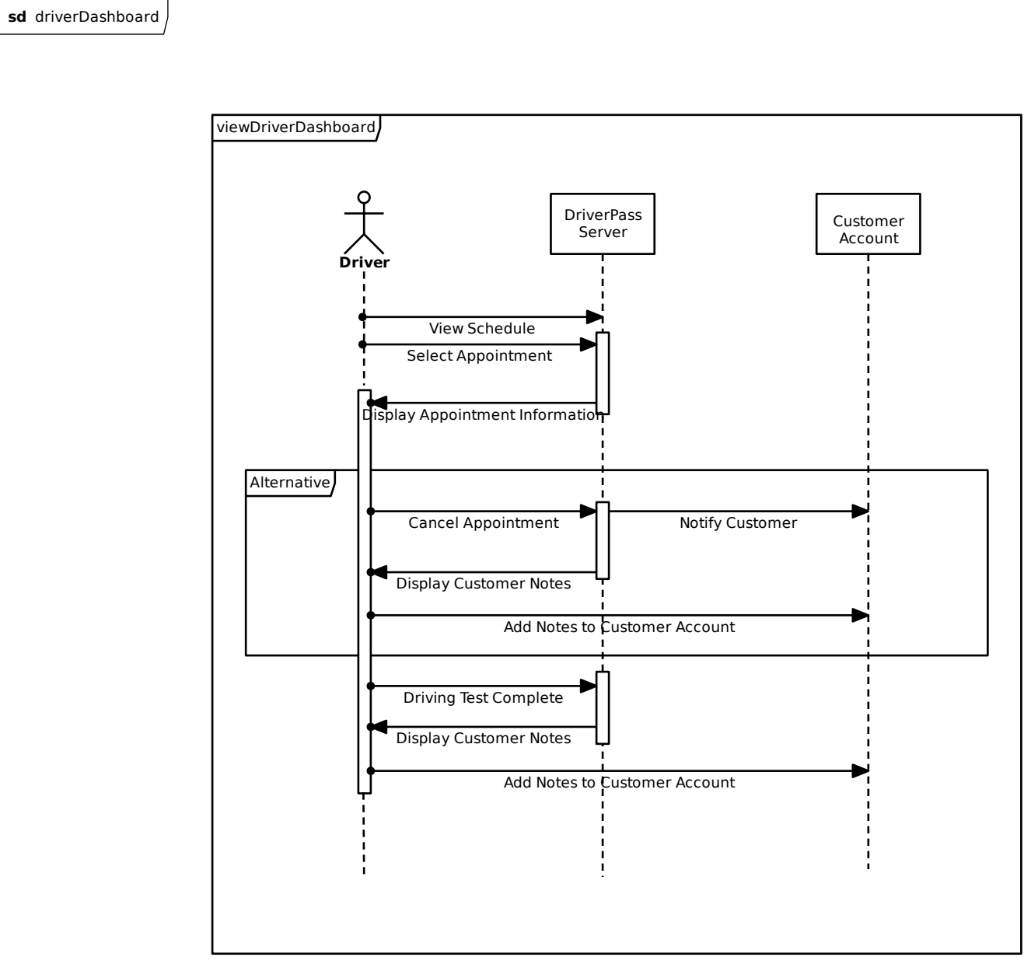

### UML Class Diagram

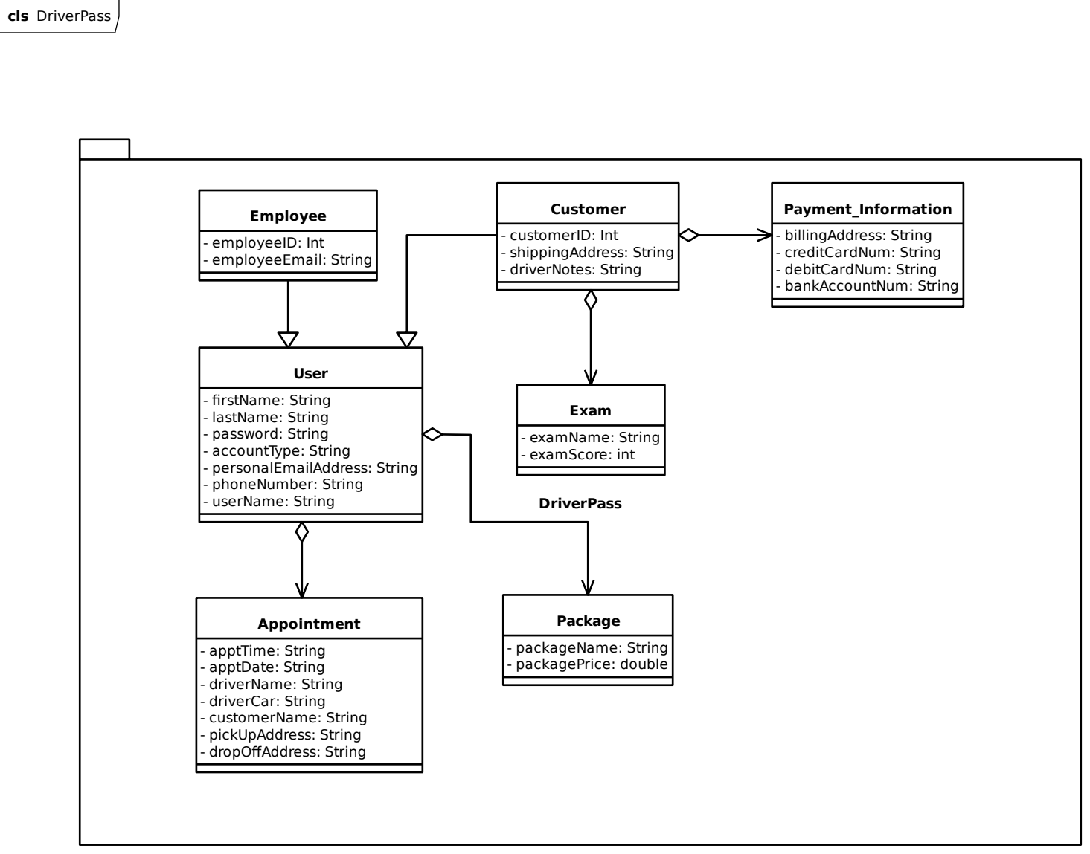

## Technical Requirements

The system will be cloud-based and maintained by the cloud provider chosen. I recommended DigitalOcean in our Business Requirements and I still recommend DigitalOcean for deployment. This will relieve the necessity for DriverPass to purchase any hardware for the system. DigitalOcean provides database maintenance and will scale according to the needs of our client. The infrastructure of the app and site shall follow RESTful principles for added security through the use of well defined user roles and performance. Assurance that the DMV will update the DriverPass system will be required prior to deployment. If they are uncooperative, the system will need to be changed to analyze the documents, most likely in PDF format, provided by the DMV for any changes between the current data and the updated information. Two-factor authorization is recommended and will be implemented as standard unless the client says otherwise.